RESUME

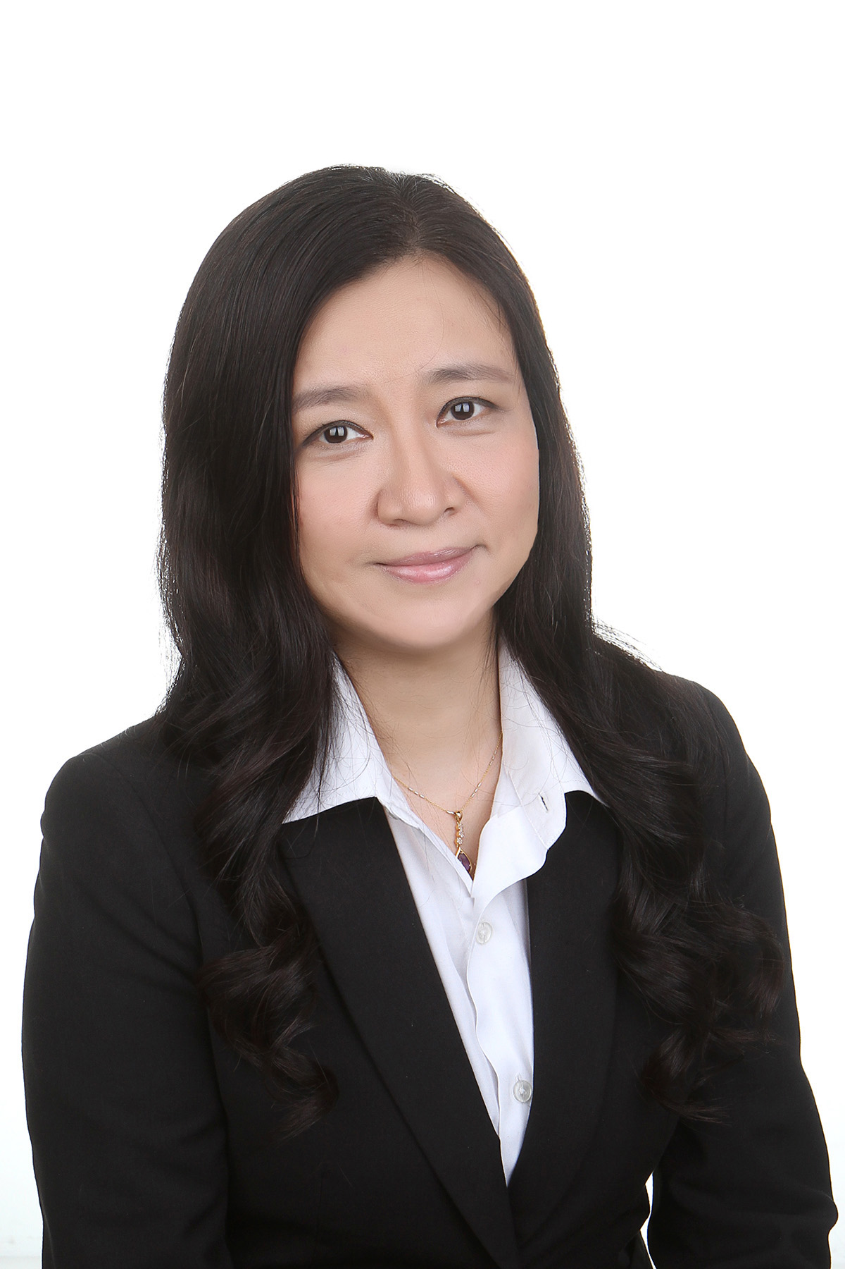

PERSONAL DETAILS
- Name/Age: Jane Huang/47yrs | - Contact: (65) 9180 8672
- Nationality: Singaporean | - Email: huangjane21@yahoo.com.sg

PROFESSIONAL SUMMARY
- Above 25 years in finance and accounting

- Above 12 years as CFO, Group Finance Director, Group Financial Controller or Head of Finance for MNCs, SGX listed companies, REITs and pre-IPO companies.

- Multi-industry Exposure:

  - Real Estate/REIT/Property Development/Property Management/Hotel

- REIT: As IPO CFO, managed the entire listing process and successfully listed EC World REIT on SGX Mainboard in July 2016. (2015-2017)

- Property Development and Property Management (Residential/Retail Mall//Hotel): As Group Financial Controller (Finance Head for Guocoland China region), managed the property development and property management business of the residential properties, retail malls and hotels in the entire China region for Hong Leong Group property sector. (2011-2012)

  - Healthcare/Medical
As IPO CFO/Group Financial Controller (HQ), managed the entire listing process and successfully listed Q&M Dental Group on SGX Mainboard in November 2009. (2008-2010)

  - Energy/Power/Engineering
As Group Financial Controller for the power sector (power plant investment, construction and operation) of a major Thai listed engineering group. (2013-2015)

  - Technology/Chemical/Electronics – Manufacturing/Distribution/Services
-As Head of Finance and Controlling (ASEAN) for a large MNC in the manufacturing and distribution of chemical products. (2003-2006)
-As Group Finance Manager (HQ) for a sizable SGX listed group in the manufacturing and distribution of electronic and technological products and services. (2000-2003)

- Regional Exposure
  - Regional exposure covers mainly Singapore, China, Thailand, Philippines, Malaysia and some other countries in the ASEAN and APAC regions.

MAJOR COMPETENCES AND ACHIEVEMENTS
Major Competences | Achievements
IPO/SGX Listing  (CFO role)  - SGX/MAS regulations  - Security market  - Investor psychology  - Good business acumen  - Compliance  - Corporate governance | Successfully listed:  -EC World REIT, on SGX Mainboard in July 2016 (CFO role)  -Q&M Dental Group, on SGX Mainboard in November 2009 (CFO role)  -Radiance Group, on SGX Catalist (fna Sesdaq) in June 2003 (HQ Group Finance Manager role)
Treasury/Funds raising  (CFO role) | -Raised equivalent to S$406 million syndicate loan for ECW REIT in 2016  -Raised S$630 million thru IPO for ECW REIT in 2016  -Raised RMB1,000 million property and working capital loan for Guocoland (China Region) during 2011 and 2012  -Raised S$75 million thru IPO for Q&M Dental Group in 2009

Major Competences (Cont’d) | Achievements (Cont’d)
Financial Modelling  Financial Planning &Analysis  (CFO role, hands-on) | Strong financial modelling skill for financial forecast and FP&A contributed to:  - a proper IPO structure to help achieve the high-level yield required by the REIT market, which was one of the most important key success factors for EC World listing.  - proper FP&A for business model and growth structure to meet management and market expectation of financial growth and risk exposure.
Financial Shared Service  (Finance head role) | As Group/Regional finance head, to have managed the Financial Shared Service team for MNCs and SGX- listed companies like Degussa SEA, Guocoland (China Region) and Q&M Dental Group etc, and achieved significant improvements in the financial and management reporting sectors while making significant cost savings as well.
Reporting/Analysis/System  -SGX/MAS/Statutory reporting  -Reporting/Analysis automation  -System design & implementation | -Achieved consistently high level of reporting and analysis in both quality and efficiency aspects, for all companies in charge thru high level hands-on ability in adapting flexibly in reporting and analysis automation and financial modelling and a highly committed and detailed work style.  -Having led the system design and implementation processes for EC World REIT, Q&M Dental Group and Degussa etc.
Budget, Control, Workflow and Risk  -Budget/Forecast/CAPEX  -Internal Control  -Process and workflow  -Risk Management | Achieved major improvements, mainly to achieve better efficiency, better asset protection and risk control, for most employers since year 2000, in budget/forecast/CAPEX, internal control policies and procedures, process and workflow improvements.
Tax/Transfer Pricing  -regional tax planning  -transfer pricing  -tax compliance | Significant tax savings and better tax compliance achieved for ECW REIT, Toyo Thai, Guocoland (China), Q&M Dental Group and Degussa SEA etc, under guidance of the tax consultants engaged.
M&A | -Participated actively in M&A processes including industry and company analysis, review of offering materials, valuation modelling, coordination of due diligence process and contract negotiation etc.  -Provided major assistance in the acquisition of projects and companies for ECW REIT, Toyo Thai Power, Guocoland (China) and Q&M Dental etc.

DETAILED WORKING EXPERIENCE

Aug 2015 – Present EC World REIT/EC World Asset Management Pte Ltd and its related company

Position Held IPO CFO/Head of Finance

Core Responsibilities
- To manage the entire IPO process for the listing of EC World REIT (successfully listed on SGX Mainboard on 28th July 2016), and

-To manage full spectrum of the group’s financing, financial and management reporting, financial modelling and system implementation, control, budget and forecast, tax, and to assist in project investment, M&A, HR, company secretarial and legal related matters.

Details cover mainly:
- Senior-level responsibility for the success of the IPO and the preparation of the IPO prospectus documents
- Dealing with IPO Lead Manager and lawyers to structure the IPO
- Financial modeling for IPO forecast and projections
- Funds raising for loan restructuring for the IPO
- SGX/MAS queries for the IPO
- Roadshow presentation and meetings with investors and analysts
- To develop and implement an efficient accounting and financial reporting system, with reporting automation
- SGX financial results announcements, analysis and dividend distribution
- Internal control policies and procedures
- Financial and accounting processes, workflow and policies
- Legal, HR and company secretarial matters for start-up companies

Reporting To CEO/Executive Director
Industry REIT/Real Estate/Private Equity Fund
Regions Covered Singapore, China, APAC

Reason for Leaving To pursue better career opportunities after successful completion of the IPO project

____________________________________________________________________________________________________________________________________________________________________________________________________________

Jun 2013 – Aug 2015 Toyo Thai Power Holdings Pte Ltd and its related company

Position Held IPO CFO/Group Financial Controller/Financial Consultant

Core Responsibilities
-To manage the pre-IPO process for the prospective listing of Toyo Thai Power on SGX Mainboard, and

-To manage full spectrum of the group’s financing, financial and management reporting, financial modelling and system implementation, control, budget and forecast, tax, and to assist in project investment, M&A, HR, company secretarial and legal related matters.

Details cover mainly:
- Leading the pre-IPO process for a prospective SGX Mainboard listing
- Financial modeling for potential business opportunities and M&A projects
- Project feasibility studies and investment appraisals
- Reporting automation
- Annual report and other reporting and analysis matters
- Internal control policies and procedures, and accounting process and workflow
- Budget and forecast
- Cash flow and treasury control
- Work with the tax consultant on regional tax planning, tax compliance and statutory tax reporting matters
- EDB, legal, HR and company secretarial matters for start-up companies

Reporting To CEO/Managing Director
Industry Power & Utilities (Power plant investment, construction and operation)
Regions Covered Singapore, Thailand, Myanmar, Japan

Reason for Leaving To pursue better career opportunity due to IPO project on-hold as a result of major changes in shareholding structure and major delay in power project progress.

____________________________________________________________________________________________________________________________________________________________________________________________________________

Jun 2010 – Dec 2012 Overseas Posting (overseas project & family relocation)

Company Name Guoson Investment Company Limited (Guocoland China HQ)
(Member of Hong Leong Group, 100% owned by SGX mainboard listed Guocoland Ltd)

Position Held Group Financial Controller (i.e. China Region Head of Finance)
(Overseas Contract Aug 2011-Nov 2012)

Core Responsibilities
To manage full spectrum of the group's financing, accounting, reporting, taxation, controlling, risk management, project investment and M&A functions, including mainly:
- Group treasury, funds raising and working capital management
- Group reporting, financial analysis and reporting automation
- Group tax planning, tax compliance and tax reporting
- Internal control and budgetary control system, work flow and process improvement
- Overall group profit maximisation & risk control
- Major participation in strategic management, inclusive of but not limited to group financial decisions, strategic financial planning, capital investments, mergers and acquisitions, overall management and development decisions etc.
- Managing relationships with relevant government bodies and important stakeholders, including shareholders, investors, capital market security analysts, banks & financial institutions, tax authorities, auditors, and SAFE (i.e. State Administration of Foreign Exchange) etc.
- To set-up and manage a sizable Financial Shared Service team of 18 persons at group level, 8 project finance managers, and an internal audit team of 2 persons

Reporting To Group Managing Director (China HQ)
Industry Property Development, Property Management (Residential Property/Retail Mall/Hotel)
Region Covered China (Beijing, Shanghai, Tianjin, Nanjing)

Reason for Leaving Family relocation back to Singapore in Jan 2013 for daughter’s education

___________________________________________________________________________________________________________________________________________________________________________________________________________

Jun 2008 – May 2010 Q&M Dental Group (Singapore) Limited

Position Held IPO CFO/Group Financial Controller

Core Responsibilities
- To manage the entire IPO process for the listing of Q&M Dental (successfully listed on SGX Mainboard in Nov 2009), and

-To manage full spectrum of the group’s financing, financial and management reporting, financial modelling and system implementation, control, budget and forecast, tax, and to assist in project investment, M&A, HR, company secretarial and legal related matters.

Details cover mainly:
- Leading the whole IPO process
  - To structure the IPO with the Lead Manager and the lawyers
  - To structure the automated financial forecast model to assist board decisions on business directions
  - To be in charge of the 3years historical financial statements and forecast preparation for the listing exercise
  - Major involvement in IPO Prospectus preparation with the Lead Manager and the IPO lawyer
  - Board memo preparation in respect of the listing exercise
  - To attend verification meetings with lead manager, auditor, lawyer and directors
  - Road show presentation and meetings with investors and analysts
- To manage the Financial Shared Service team of 10 persons at HQ level, no accounting staff at the 40 subsidiaries.
- Accounting system implementation (ERP) and reporting automation
- Annual reports, SGX financial results announcements, and financial analysis
- Internal control policies and procedures
- Cash flow and treasury management
- Tax planning and tax compliance

Reporting To Group CEO
Industry Healthcare, Dental Clinical Services & Distribution, Dental Lab & Dental Institution

Regions Covered Singapore, China

Reason for Leaving Family relocation to Beijing to join husband (who had been on overseas assignment since 2007) after successful completion of the IPO project.

____________________________________________________________________________________________________________________________________________________________________________________________________________

Aug 2003 – Sep 2006 Degussa (SEA) Pte Ltd (German MNC/Listed Company)

Position Held Head of Finance and Controlling (ASEAN Region Financial Shared Service)

Core Responsibilities
To lead the financial shared service platform to be in charge of the overall financing, accounting, reporting, taxation, treasury and controlling activities of all Degussa companies under charge in the ASEAN region. Key accountabilities include mainly:
- System implementation/reporting and analysis automation
- Financial/accounting/internal control policies and procedures
- Financial analysis and planning
- Cash flow planning, working capital and funds management
- Inventory Management
- Annual report
- Tax planning and tax compliance
- Budget and forecast
- To review and analyze business financial performance and provide advisory support to business units
- To liaise with various business unit heads, internal and external auditors, tax agents and tax authorities, banks and other financial institutions, and other relevant authorities.
- To manage, motivate and develop members of the finance team (SSC for ASEAN region), maximizing team potential.

Reporting To Regional President ASEAN
Industry Chemical manufacturing, distribution and R&D
Regions Covered Singapore & other ASEAN countries

Reason for Leaving Lack of trustworthy caretaker for 1 year old daughter at time of resignation

____________________________________________________________________________________________________________________________________________________________________________________________________________

Dec 2000 – Aug 2003 Goldtron Limited (MNC/SGX listed)

Position Held Group Finance Manager (at group ultimate holding company level)

Core Responsibilities
To provide major support to the Group CFO cum Executive Director for the successful listing of its major subsidiary Radiance Group on SGX, and to assist the Group CFO in managing the group’s finance, reporting, tax, controlling and treasury functions. The Group had 40 over subsidiaries in Singapore, China, Malaysia, Taiwan and US.
Key accountabilities include mainly:
- Stock exchange financial results announcement
- Annual report of the group and the holding company
- Group tax planning
- Group internal control procedures, accounting practices and compliance issues, inclusive of the preparation of the Group Internal Control Manual etc
- Group treasury management and cash flow planning
- Group budget and forecast
- System implementation: the establishment of automated group consolidated reporting and financial analysis
- The successful listing of major subsidiary Radiance Group (Jun2003 SGX): major assistance to the CFO for the IPO
- To assist the Group CFO in the evaluation of M&A, investment, business development and other ad hoc projects

Reporting To Group CFO cum Executive Director
Industry Electronics manufacturing, component distribution, trading and investment holding
Regions Covered Singapore, China, Malaysia, Taiwan, USA

Reason for Leaving Career development

____________________________________________________________________________________________________________________________________________________________________________________________________________

PROFESSIONAL AND ACADEMIC QUALIFICATIONS
- FCCA Member since 2007 Professional qualification in Accountancy
- CA/CPA Singapore Member since 2004 Professional qualification in Accountancy
- ACCA Member since 2002 Professional qualification in Accountancy
- Degree (BSc) Graduated in 1991 Degree in Management

LANGUAGE CAPABILITY
- English Native fluency | - Chinese Native fluency

KEY PERSONALITIES LEADING TO SUCCESS
- Strong leadership quality
- Good communication skills and management capabilities
- A strong will to success and excellence
- Very committed and result-oriented
- Good analytical skill
- Good business acumen
- Meticulous and hands-on

REFERENCES
Very good references from direct reporting persons or senior management from all ex-employers

